Part-I: Problem Statement & ER Diagram

Problem Statement
Managing a university hostel is a complex administrative challenge that involves tracking students, room allocations, staff, maintenance requests, payments, and visitor records. Traditional paper-based or spreadsheet-based systems are error-prone, difficult to scale, and lack the relational integrity needed for accurate reporting and query-driven decisions.

The Hostel Management System (HMS) is a relational database-backed platform designed for COMSATS University Islamabad to digitize and streamline all hostel operations. The system enables administrators to manage room allocations in real-time, track fee payments, handle maintenance requests, monitor visitor access, manage hostel staff, record student complaints, schedule laundry services, manage inventory, process room transfer requests, manage mess/canteen menus, and assign lockers — all through a unified, consistent, and queryable data model.

Key Features of the Platform
- Student registration and room allocation management
- Multi-type room inventory (Single, Double, Triple, Dormitory) across multiple blocks and floors
- Fee generation, tracking, and payment recording per student
- Maintenance request lifecycle management (Pending → In Progress → Resolved)
- Visitor log management with entry/exit timestamps and staff approval
- Staff management with role assignments, shift tracking, and salary records
- Student complaint/grievance portal with resolution tracking
- Laundry scheduling and service management per student
- Hostel inventory and asset management (furniture, appliances, consumables)
- Room transfer request management with approval workflow
- Mess/canteen menu planning and meal subscription management
- Locker assignment and management for student belongings

Entity Identification & Descriptions
# | Entity | Description | Key Attributes
1 | STUDENT | Represents a hostel resident enrolled at COMSATS. Core entity of the system. | student_id (PK), name, cnic, contact, room_id (FK)
2 | ROOM | A physical room in the hostel with type, capacity, and floor details. | room_id (PK), room_number, floor, type, capacity, status
3 | PAYMENT | Records fee payments made by students for their accommodation. | payment_id (PK), student_id (FK), amount, date, method, status
4 | MAINTENANCE | Logs maintenance/repair requests raised for hostel facilities. | request_id (PK), room_id (FK), reported_by (FK), description, status
5 | VISITOR | Records details of visitors who come to meet hostel residents. | visitor_id (PK), student_id (FK), visitor_name, purpose, entry_time
6 | STAFF | Hostel staff including wardens, cleaners, guards, and technicians. | staff_id (PK), name, role, contact, shift, hire_date
7 | COMPLAINT | Student-raised grievances or complaints regarding hostel facilities or conduct. | complaint_id (PK), student_id (FK), category, description, status, resolved_by (FK)
8 | LAUNDRY | Tracks laundry service requests submitted by students. | laundry_id (PK), student_id (FK), submitted_date, return_date, items_count, status
9 | INVENTORY | Manages hostel assets and consumable items assigned to rooms or common areas. | item_id (PK), item_name, category, quantity, room_id (FK), condition
10 | ROOM_TRANSFER | Records student requests to move from one room to another, with approval and assignment tracking. | transfer_id (PK), student_id (FK), from_room_id (FK), to_room_id (FK), reason, status, requested_date, approved_by (FK)
11 | MESS_MENU | Stores weekly mess/canteen meal plans and student meal subscriptions. | menu_id (PK), day, meal_type, description, calories, prepared_by (FK)
12 | LOCKER | Tracks locker units assigned to students for securing personal belongings. | locker_id (PK), locker_number, block, student_id (FK), assigned_date, status

Entity Relationships
Relationship | Entity 1 | Entity 2 | Multiplicity | Description
ASSIGNED_TO | STUDENT | ROOM | M:1 | Many students can be assigned to one room (based on capacity)
MAKES | STUDENT | PAYMENT | 1:M | One student can make many payments over their stay
REPORTED_BY | STUDENT | MAINTENANCE | 1:M | A student can report multiple maintenance issues
RELATED_TO | ROOM | MAINTENANCE | 1:M | A room can have many maintenance requests
HAS | STUDENT | VISITOR | 1:M | A student can receive many visitors over time
MANAGED_BY | ROOM | STAFF | M:N | Staff manage multiple rooms; rooms can be managed by multiple staff
RAISES | STUDENT | COMPLAINT | 1:M | A student can raise multiple complaints during their stay
SUBMITS | STUDENT | LAUNDRY | 1:M | A student can submit multiple laundry requests
CONTAINS | ROOM | INVENTORY | 1:M | A room can contain multiple inventory items
REQUESTS | STUDENT | ROOM_TRANSFER | 1:M | A student can submit multiple room transfer requests during their stay
SUBSCRIBES_TO | STUDENT | MESS_MENU | M:N | A student subscribes to meal plans; a meal plan can have many subscribers
ASSIGNED | STUDENT | LOCKER | 1:1 | Each student is assigned at most one locker at a time

Entity-Relationship Diagram (ERD)

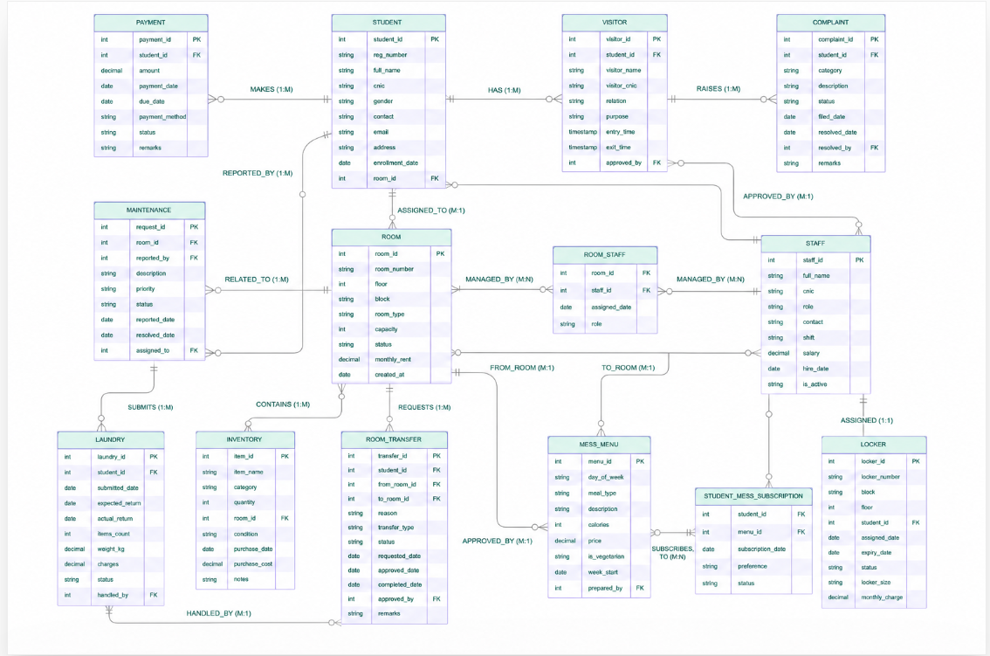

Part-II: Relational Schema & DDL Script

Relational Schema Overview
The following 12 tables were derived directly from the ERD. All primary keys, foreign keys, NOT NULL constraints, CHECK constraints, and DEFAULT values are explicitly defined in the DDL.
The following 12 tables were derived directly from the ERD. All primary keys, foreign keys, NOT NULL constraints, CHECK constraints, and DEFAULT values are explicitly defined in the DDL.
ROOM (room_id PK, room_number, floor, block, room_type, capacity, status, monthly_rent, created_at)

STUDENT (student_id PK, reg_number, full_name, cnic, gender, contact, email, address, enrollment_date, room_id FK→ROOM)

STAFF (staff_id PK, full_name, cnic, role, contact, shift, salary, hire_date, is_active)

PAYMENT (payment_id PK, student_id FK→STUDENT, amount, payment_date, due_date, payment_method, status, remarks)

MAINTENANCE (request_id PK, room_id FK→ROOM, reported_by FK→STUDENT, description, priority, status, reported_date, resolved_date, assigned_to FK→STAFF)

VISITOR (visitor_id PK, student_id FK→STUDENT, visitor_name, visitor_cnic, relation, purpose, entry_time, exit_time, approved_by FK→STAFF)

COMPLAINT (complaint_id PK, student_id FK→STUDENT, category, description, status, filed_date, resolved_date, resolved_by FK→STAFF, remarks)

LAUNDRY (laundry_id PK, student_id FK→STUDENT, submitted_date, expected_return, actual_return, items_count, weight_kg, charges, status, handled_by FK→STAFF)

INVENTORY (item_id PK, item_name, category, quantity, room_id FK→ROOM, condition, purchase_date, purchase_cost, notes)

ROOM_TRANSFER(transfer_id PK, student_id FK, from_room_id FK, to_room_id FK, reason, transfer_type, status, requested_date, approved_date, completed_date, approved_by FK, remarks)

MESS_MENU (menu_id PK, day_of_week, meal_type, description, calories, price, is_vegetarian, week_start, prepared_by FK→STAFF)

LOCKER (locker_id PK, locker_number, block, floor, student_id FK→STUDENT, assigned_date, expiry_date, status, locker_size, monthly_charge)

Table 1: ROOM
CREATE TABLE ROOM (
room_id NUMBER(5) PRIMARY KEY,
room_number VARCHAR2(10) NOT NULL UNIQUE,
floor NUMBER(2) NOT NULL,
block VARCHAR2(5) NOT NULL,
room_type VARCHAR2(20) NOT NULL CHECK (room_type IN ('Single','Double','Triple','Dormitory')),
capacity NUMBER(2) NOT NULL,
status VARCHAR2(20) DEFAULT 'Available'
CHECK (status IN ('Available','Occupied','Under Maintenance')),
monthly_rent NUMBER(8,2) NOT NULL,
created_at DATE DEFAULT SYSDATE
);

Table 2: STUDENT
CREATE TABLE STUDENT (
student_id NUMBER(7) PRIMARY KEY,
reg_number VARCHAR2(20) NOT NULL UNIQUE,
full_name VARCHAR2(100) NOT NULL,
cnic VARCHAR2(15) NOT NULL UNIQUE,
gender VARCHAR2(10) CHECK (gender IN ('Male','Female','Other')),
contact VARCHAR2(15) NOT NULL,
email VARCHAR2(100) NOT NULL UNIQUE,
address VARCHAR2(200),
enrollment_date DATE DEFAULT SYSDATE,
room_id NUMBER(5),
CONSTRAINT fk_student_room FOREIGN KEY (room_id) REFERENCES ROOM(room_id)
);

Table 3: STAFF
CREATE TABLE STAFF (
staff_id NUMBER(5) PRIMARY KEY,
full_name VARCHAR2(100) NOT NULL,
cnic VARCHAR2(15) NOT NULL UNIQUE,
role VARCHAR2(30) NOT NULL
CHECK (role IN ('Warden','Assistant Warden','Guard','Cleaner','Technician','Cook')),
contact VARCHAR2(15) NOT NULL,
shift VARCHAR2(10) CHECK (shift IN ('Morning','Evening','Night')),
salary NUMBER(10,2),
hire_date DATE DEFAULT SYSDATE,
is_active VARCHAR2(3) DEFAULT 'Yes' CHECK (is_active IN ('Yes','No'))
);

Table 4: PAYMENT
CREATE TABLE PAYMENT (
payment_id NUMBER(7) PRIMARY KEY,
student_id NUMBER(7) NOT NULL,
amount NUMBER(10,2) NOT NULL,
payment_date DATE DEFAULT SYSDATE,
due_date DATE NOT NULL,
payment_method VARCHAR2(20) CHECK (payment_method IN ('Cash','Bank Transfer','Online','Cheque')),
status VARCHAR2(15) DEFAULT 'Pending'
CHECK (status IN ('Paid','Pending','Overdue')),
remarks VARCHAR2(200),
CONSTRAINT fk_payment_student FOREIGN KEY (student_id) REFERENCES STUDENT(student_id)
);

Table 5: MAINTENANCE
CREATE TABLE MAINTENANCE (
request_id NUMBER(7) PRIMARY KEY,
room_id NUMBER(5) NOT NULL,
reported_by NUMBER(7) NOT NULL,
description VARCHAR2(500) NOT NULL,
priority VARCHAR2(10) DEFAULT 'Medium'
CHECK (priority IN ('Low','Medium','High','Critical')),
status VARCHAR2(20) DEFAULT 'Pending'
CHECK (status IN ('Pending','In Progress','Resolved','Cancelled')),
reported_date DATE DEFAULT SYSDATE,
resolved_date DATE,
assigned_to NUMBER(5),
CONSTRAINT fk_maint_room FOREIGN KEY (room_id) REFERENCES ROOM(room_id),
CONSTRAINT fk_maint_student FOREIGN KEY (reported_by) REFERENCES STUDENT(student_id),
CONSTRAINT fk_maint_staff FOREIGN KEY (assigned_to) REFERENCES STAFF(staff_id)
);

Table 6: VISITOR
CREATE TABLE VISITOR (
visitor_id NUMBER(7) PRIMARY KEY,
student_id NUMBER(7) NOT NULL,
visitor_name VARCHAR2(100) NOT NULL,
visitor_cnic VARCHAR2(15),
relation VARCHAR2(30),
purpose VARCHAR2(200),
entry_time TIMESTAMP DEFAULT SYSTIMESTAMP,
exit_time TIMESTAMP,
approved_by NUMBER(5),
CONSTRAINT fk_visitor_student FOREIGN KEY (student_id) REFERENCES STUDENT(student_id),
CONSTRAINT fk_visitor_staff FOREIGN KEY (approved_by) REFERENCES STAFF(staff_id)
);

Table 7: COMPLAINT
CREATE TABLE COMPLAINT (
complaint_id NUMBER(7) PRIMARY KEY,
student_id NUMBER(7) NOT NULL,
category VARCHAR2(50) NOT NULL
CHECK (category IN ('Noise','Food','Cleanliness','Behavior','Facilities','Other')),
description VARCHAR2(500) NOT NULL,
status VARCHAR2(20) DEFAULT 'Open'
CHECK (status IN ('Open','Under Review','Resolved','Rejected')),
filed_date DATE DEFAULT SYSDATE,
resolved_date DATE,
resolved_by NUMBER(5),
remarks VARCHAR2(300),
CONSTRAINT fk_complaint_student FOREIGN KEY (student_id) REFERENCES STUDENT(student_id),
CONSTRAINT fk_complaint_staff FOREIGN KEY (resolved_by) REFERENCES STAFF(staff_id)
);

Table 8: LAUNDRY
CREATE TABLE LAUNDRY (
laundry_id NUMBER(7) PRIMARY KEY,
student_id NUMBER(7) NOT NULL,
submitted_date DATE DEFAULT SYSDATE,
expected_return DATE NOT NULL,
actual_return DATE,
items_count NUMBER(3) NOT NULL,
weight_kg NUMBER(5,2),
charges NUMBER(8,2),
status VARCHAR2(20) DEFAULT 'Submitted'
CHECK (status IN ('Submitted','In Process','Ready','Delivered')),
handled_by NUMBER(5),
CONSTRAINT fk_laundry_student FOREIGN KEY (student_id) REFERENCES STUDENT(student_id),
CONSTRAINT fk_laundry_staff FOREIGN KEY (handled_by) REFERENCES STAFF(staff_id)
);

Table 9: INVENTORY
CREATE TABLE INVENTORY (
item_id NUMBER(7) PRIMARY KEY,
item_name VARCHAR2(100) NOT NULL,
category VARCHAR2(50) NOT NULL
CHECK (category IN ('Furniture','Appliance','Bedding','Cleaning','Electronics','Other')),
quantity NUMBER(5) DEFAULT 1 NOT NULL,
room_id NUMBER(5),
condition VARCHAR2(15) DEFAULT 'Good'
CHECK (condition IN ('New','Good','Fair','Damaged','Disposed')),
purchase_date DATE,
purchase_cost NUMBER(10,2),
notes VARCHAR2(300),
CONSTRAINT fk_inventory_room FOREIGN KEY (room_id) REFERENCES ROOM(room_id)
);

Table 10: ROOM_TRANSFER
CREATE TABLE ROOM_TRANSFER (
transfer_id NUMBER(7) PRIMARY KEY,
student_id NUMBER(7) NOT NULL,
from_room_id NUMBER(5) NOT NULL,
to_room_id NUMBER(5) NOT NULL,
reason VARCHAR2(400) NOT NULL,
transfer_type VARCHAR2(30) DEFAULT 'Personal'
CHECK (transfer_type IN ('Medical','Noise Issue','Personal','Maintenance','Upgrade','Downgrade')),
status VARCHAR2(20) DEFAULT 'Pending'
CHECK (status IN ('Pending','Approved','Rejected','Completed','Cancelled')),
requested_date DATE DEFAULT SYSDATE,
approved_date DATE,
completed_date DATE,
approved_by NUMBER(5),
remarks VARCHAR2(200),
CONSTRAINT fk_transfer_student FOREIGN KEY (student_id) REFERENCES STUDENT(student_id),
CONSTRAINT fk_transfer_from_room FOREIGN KEY (from_room_id) REFERENCES ROOM(room_id),
CONSTRAINT fk_transfer_to_room FOREIGN KEY (to_room_id) REFERENCES ROOM(room_id),
CONSTRAINT fk_transfer_staff FOREIGN KEY (approved_by) REFERENCES STAFF(staff_id)
);

Table 11: MESS_MENU
CREATE TABLE MESS_MENU (
menu_id NUMBER(7) PRIMARY KEY,
day_of_week VARCHAR2(10) NOT NULL
CHECK (day_of_week IN ('Monday','Tuesday','Wednesday','Thursday','Friday','Saturday','Sunday')),
meal_type VARCHAR2(15) NOT NULL
CHECK (meal_type IN ('Breakfast','Lunch','Dinner','Snack')),
description VARCHAR2(500) NOT NULL,
calories NUMBER(5),
price NUMBER(7,2),
is_vegetarian VARCHAR2(3) DEFAULT 'No' CHECK (is_vegetarian IN ('Yes','No')),
week_start DATE NOT NULL,
prepared_by NUMBER(5),
CONSTRAINT fk_menu_staff FOREIGN KEY (prepared_by) REFERENCES STAFF(staff_id)
);

Table 12: LOCKER
CREATE TABLE LOCKER (
locker_id NUMBER(7) PRIMARY KEY,
locker_number VARCHAR2(10) NOT NULL UNIQUE,
block VARCHAR2(5) NOT NULL,
floor NUMBER(2) NOT NULL,
student_id NUMBER(7),
assigned_date DATE,
expiry_date DATE,
status VARCHAR2(15) DEFAULT 'Available'
CHECK (status IN ('Available','Assigned','Maintenance')),
locker_size VARCHAR2(10) DEFAULT 'Medium'
CHECK (locker_size IN ('Small','Medium','Large')),
monthly_charge NUMBER(7,2),
CONSTRAINT fk_locker_student FOREIGN KEY (student_id) REFERENCES STUDENT(student_id)
);

Part-III: Sample Data Insertion
The following SQL INSERT statements populate each table with a minimum of 30 realistic sample tuples for the Hostel Management System.

Table 1: ROOM — 30 Records
INSERT INTO ROOM VALUES (101,'R-101',1,'A','Single',1,'Available',8000,SYSDATE);
INSERT INTO ROOM VALUES (102,'R-102',1,'A','Double',2,'Occupied',6000,SYSDATE);
INSERT INTO ROOM VALUES (103,'R-103',1,'A','Triple',3,'Available',5000,SYSDATE);
INSERT INTO ROOM VALUES (104,'R-104',1,'A','Dormitory',6,'Occupied',3500,SYSDATE);
INSERT INTO ROOM VALUES (105,'R-105',1,'A','Single',1,'Occupied',8000,SYSDATE);
INSERT INTO ROOM VALUES (106,'R-106',1,'B','Double',2,'Available',6000,SYSDATE);
INSERT INTO ROOM VALUES (107,'R-107',1,'B','Triple',3,'Occupied',5000,SYSDATE);
INSERT INTO ROOM VALUES (108,'R-108',1,'B','Single',1,'Available',8500,SYSDATE);
INSERT INTO ROOM VALUES (109,'R-109',2,'A','Double',2,'Occupied',6500,SYSDATE);
INSERT INTO ROOM VALUES (110,'R-110',2,'A','Single',1,'Under Maintenance',8000,SYSDATE);
INSERT INTO ROOM VALUES (111,'R-111',2,'A','Dormitory',8,'Available',3000,SYSDATE);
INSERT INTO ROOM VALUES (112,'R-112',2,'B','Double',2,'Occupied',6000,SYSDATE);
INSERT INTO ROOM VALUES (113,'R-113',2,'B','Single',1,'Available',8000,SYSDATE);
INSERT INTO ROOM VALUES (114,'R-114',2,'B','Triple',3,'Occupied',4800,SYSDATE);
INSERT INTO ROOM VALUES (115,'R-115',3,'A','Single',1,'Available',8000,SYSDATE);
INSERT INTO ROOM VALUES (116,'R-116',3,'A','Double',2,'Occupied',6200,SYSDATE);
INSERT INTO ROOM VALUES (117,'R-117',3,'A','Triple',3,'Occupied',5000,SYSDATE);
INSERT INTO ROOM VALUES (118,'R-118',3,'B','Dormitory',6,'Available',3500,SYSDATE);
INSERT INTO ROOM VALUES (119,'R-119',3,'B','Single',1,'Occupied',8000,SYSDATE);
INSERT INTO ROOM VALUES (120,'R-120',3,'B','Double',2,'Available',6000,SYSDATE);
INSERT INTO ROOM VALUES (121,'R-121',4,'A','Single',1,'Occupied',8500,SYSDATE);
INSERT INTO ROOM VALUES (122,'R-122',4,'A','Triple',3,'Available',5000,SYSDATE);
INSERT INTO ROOM VALUES (123,'R-123',4,'A','Double',2,'Occupied',6000,SYSDATE);
INSERT INTO ROOM VALUES (124,'R-124',4,'B','Single',1,'Available',8000,SYSDATE);
INSERT INTO ROOM VALUES (125,'R-125',4,'B','Dormitory',6,'Occupied',3200,SYSDATE);
INSERT INTO ROOM VALUES (126,'R-126',5,'A','Single',1,'Available',8000,SYSDATE);
INSERT INTO ROOM VALUES (127,'R-127',5,'A','Double',2,'Occupied',6000,SYSDATE);
INSERT INTO ROOM VALUES (128,'R-128',5,'B','Triple',3,'Available',4800,SYSDATE);
INSERT INTO ROOM VALUES (129,'R-129',5,'B','Single',1,'Occupied',8000,SYSDATE);
INSERT INTO ROOM VALUES (130,'R-130',5,'B','Double',2,'Available',6000,SYSDATE);

Table 2: STUDENT — 30 Records
INSERT INTO STUDENT VALUES (1001,'SP21-BSE-001','Ali Hassan','3520112345671','Male','0300-1234567','ali@comsats.edu.pk','Rawalpindi',SYSDATE,102);
INSERT INTO STUDENT VALUES (1002,'SP21-BSE-002','Fatima Malik','3520112345672','Female','0301-2345678','fatima@comsats.edu.pk','Islamabad',SYSDATE,104);
INSERT INTO STUDENT VALUES (1003,'SP21-BSE-003','Usman Tariq','3520112345673','Male','0302-3456789','usman@comsats.edu.pk','Lahore',SYSDATE,102);
INSERT INTO STUDENT VALUES (1004,'SP21-BSE-004','Ayesha Khan','3520112345674','Female','0303-4567890','ayesha@comsats.edu.pk','Karachi',SYSDATE,107);
INSERT INTO STUDENT VALUES (1005,'SP21-BSE-005','Ahmed Raza','3520112345675','Male','0304-5678901','ahmed@comsats.edu.pk','Peshawar',SYSDATE,105);
INSERT INTO STUDENT VALUES (1006,'SP21-BSE-006','Sana Butt','3520112345676','Female','0305-6789012','sana@comsats.edu.pk','Multan',SYSDATE,109);
INSERT INTO STUDENT VALUES (1007,'SP21-BSE-007','Bilal Ahmed','3520112345677','Male','0306-7890123','bilal@comsats.edu.pk','Faisalabad',SYSDATE,107);
INSERT INTO STUDENT VALUES (1008,'SP21-BSE-008','Hina Shah','3520112345678','Female','0307-8901234','hina@comsats.edu.pk','Quetta',SYSDATE,112);
INSERT INTO STUDENT VALUES (1009,'SP21-BSE-009','Zubair Iqbal','3520112345679','Male','0308-9012345','zubair@comsats.edu.pk','Sialkot',SYSDATE,104);
INSERT INTO STUDENT VALUES (1010,'SP21-BSE-010','Noor Fatima','3520112345680','Female','0309-0123456','noor@comsats.edu.pk','Gujranwala',SYSDATE,116);
INSERT INTO STUDENT VALUES (1011,'FA21-BSE-011','Shahid Mehmood','3520112345681','Male','0310-1234567','shahid@comsats.edu.pk','Bahawalpur',SYSDATE,119);
INSERT INTO STUDENT VALUES (1012,'FA21-BSE-012','Maria Perveen','3520112345682','Female','0311-2345678','maria@comsats.edu.pk','Hyderabad',SYSDATE,112);
INSERT INTO STUDENT VALUES (1013,'FA21-BSE-013','Naeem Awan','3520112345683','Male','0312-3456789','naeem@comsats.edu.pk','Abbottabad',SYSDATE,114);
INSERT INTO STUDENT VALUES (1014,'FA21-BSE-014','Shaheen Farooq','3520112345684','Female','0313-4567890','shaheen@comsats.edu.pk','Mardan',SYSDATE,117);
INSERT INTO STUDENT VALUES (1015,'FA21-BSE-015','Irfan Ali','3520112345685','Male','0314-5678901','irfan@comsats.edu.pk','Swat',SYSDATE,114);
INSERT INTO STUDENT VALUES (1016,'FA21-BSE-016','Zara Aziz','3520112345686','Female','0315-6789012','zara@comsats.edu.pk','Islamabad',SYSDATE,116);
INSERT INTO STUDENT VALUES (1017,'FA21-BSE-017','Muneeb Bashir','3520112345687','Male','0316-7890123','muneeb@comsats.edu.pk','Rawalpindi',SYSDATE,127);
INSERT INTO STUDENT VALUES (1018,'FA21-BSE-018','Amina Bibi','3520112345688','Female','0317-8901234','aminab@comsats.edu.pk','Lahore',SYSDATE,117);
INSERT INTO STUDENT VALUES (1019,'FA21-BSE-019','Saad Hussain','3520112345689','Male','0318-9012345','saad@comsats.edu.pk','Karachi',SYSDATE,125);
INSERT INTO STUDENT VALUES (1020,'FA21-BSE-020','Rabia Tariq','3520112345690','Female','0319-0123456','rabia@comsats.edu.pk','Peshawar',SYSDATE,127);
INSERT INTO STUDENT VALUES (1021,'FA21-BSE-021','Kamran Shaukat','3520112345691','Male','0320-1234567','kamran@comsats.edu.pk','Gujrat',SYSDATE,123);
INSERT INTO STUDENT VALUES (1022,'FA21-BSE-022','Sadia Naz','3520112345692','Female','0321-2345678','sadia@comsats.edu.pk','Sargodha',SYSDATE,127);
INSERT INTO STUDENT VALUES (1023,'FA21-BSE-023','Faisal Nawaz','3520112345693','Male','0322-3456789','faisal@comsats.edu.pk','Swabi',SYSDATE,125);
INSERT INTO STUDENT VALUES (1024,'FA21-BSE-024','Uzma Shahid','3520112345694','Female','0323-4567890','uzma@comsats.edu.pk','Nowshera',SYSDATE,129);
INSERT INTO STUDENT VALUES (1025,'FA21-BSE-025','Nasir Javed','3520112345695','Male','0324-5678901','nasir@comsats.edu.pk','Mardan',SYSDATE,125);
INSERT INTO STUDENT VALUES (1026,'FA22-BSE-026','Amna Shabbir','3520112345696','Female','0325-6789012','amna@comsats.edu.pk','Islamabad',SYSDATE,129);
INSERT INTO STUDENT VALUES (1027,'FA22-BSE-027','Rehan Qureshi','3520112345697','Male','0326-7890123','rehan@comsats.edu.pk','Rawalpindi',SYSDATE,104);
INSERT INTO STUDENT VALUES (1028,'FA22-BSE-028','Sobia Rashid','3520112345698','Female','0327-8901234','sobia@comsats.edu.pk','Lahore',SYSDATE,109);
INSERT INTO STUDENT VALUES (1029,'FA22-BSE-029','Umer Farhan','3520112345699','Male','0328-9012345','umer@comsats.edu.pk','Gujrat',SYSDATE,104);
INSERT INTO STUDENT VALUES (1030,'FA22-BSE-030','Irum Baig','3520112345700','Female','0329-0123456','irum@comsats.edu.pk','Sargodha',SYSDATE,109);

Table 3: STAFF — 30 Records
INSERT INTO STAFF VALUES (201,'Mr. Khalid Mahmood','3520112399001','Warden','0300-9001001','Morning',55000,DATE '2018-01-15','Yes');
INSERT INTO STAFF VALUES (202,'Ms. Rubina Ashraf','3520112399002','Assistant Warden','0301-9002002','Evening',40000,DATE '2019-03-10','Yes');
INSERT INTO STAFF VALUES (203,'Mr. Zafar Iqbal','3520112399003','Guard','0302-9003003','Night',28000,DATE '2020-06-01','Yes');
INSERT INTO STAFF VALUES (204,'Mr. Arshad Bhatti','3520112399004','Guard','0303-9004004','Morning',28000,DATE '2020-06-15','Yes');
INSERT INTO STAFF VALUES (205,'Mr. Tahir Abbas','3520112399005','Guard','0304-9005005','Evening',28000,DATE '2021-01-05','Yes');
INSERT INTO STAFF VALUES (206,'Mr. Sarwar Khan','3520112399006','Cleaner','0305-9006006','Morning',22000,DATE '2019-09-20','Yes');
INSERT INTO STAFF VALUES (207,'Mr. Akbar Ali','3520112399007','Cleaner','0306-9007007','Morning',22000,DATE '2020-02-10','Yes');
INSERT INTO STAFF VALUES (208,'Ms. Gulnaz Bibi','3520112399008','Cleaner','0307-9008008','Evening',22000,DATE '2021-05-01','Yes');
INSERT INTO STAFF VALUES (209,'Mr. Hassan Rauf','3520112399009','Technician','0308-9009009','Morning',35000,DATE '2018-11-15','Yes');
INSERT INTO STAFF VALUES (210,'Mr. Waseem Baig','3520112399010','Technician','0309-9010010','Evening',35000,DATE '2019-07-20','Yes');
INSERT INTO STAFF VALUES (211,'Mr. Nadeem Saeed','3520112399011','Cook','0310-9011011','Morning',30000,DATE '2020-01-10','Yes');
INSERT INTO STAFF VALUES (212,'Mr. Rafiq Ahmed','3520112399012','Cook','0311-9012012','Evening',30000,DATE '2020-08-05','Yes');
INSERT INTO STAFF VALUES (213,'Mr. Liaquat Shah','3520112399013','Guard','0312-9013013','Night',28000,DATE '2021-03-15','Yes');
INSERT INTO STAFF VALUES (214,'Ms. Parveen Akhtar','3520112399014','Assistant Warden','0313-9014014','Morning',40000,DATE '2020-11-01','Yes');
INSERT INTO STAFF VALUES (215,'Mr. Aftab Mirza','3520112399015','Technician','0314-9015015','Night',35000,DATE '2022-01-15','Yes');
INSERT INTO STAFF VALUES (216,'Mr. Javed Ullah','3520112399016','Cleaner','0315-9016016','Morning',22000,DATE '2022-04-10','Yes');
INSERT INTO STAFF VALUES (217,'Mr. Munir Bhatti','3520112399017','Guard','0316-9017017','Evening',28000,DATE '2022-02-20','Yes');
INSERT INTO STAFF VALUES (218,'Ms. Farida Khatoon','3520112399018','Cleaner','0317-9018018','Evening',22000,DATE '2022-06-01','Yes');
INSERT INTO STAFF VALUES (219,'Mr. Azhar Hussain','3520112399019','Cook','0318-9019019','Night',30000,DATE '2021-09-10','Yes');
INSERT INTO STAFF VALUES (220,'Mr. Ghulam Mustafa','3520112399020','Technician','0319-9020020','Morning',35000,DATE '2021-11-15','Yes');
INSERT INTO STAFF VALUES (221,'Mr. Zahid Mehmood','3520112399021','Guard','0320-9021021','Night',28000,DATE '2022-08-01','Yes');
INSERT INTO STAFF VALUES (222,'Ms. Bushra Kausar','3520112399022','Assistant Warden','0321-9022022','Evening',40000,DATE '2022-09-15','Yes');
INSERT INTO STAFF VALUES (223,'Mr. Pervez Ahmad','3520112399023','Cleaner','0322-9023023','Morning',22000,DATE '2023-01-10','Yes');
INSERT INTO STAFF VALUES (224,'Mr. Riaz Ahmed','3520112399024','Cook','0323-9024024','Morning',30000,DATE '2023-02-15','Yes');
INSERT INTO STAFF VALUES (225,'Mr. Kamran Shaukat','3520112399025','Technician','0324-9025025','Evening',35000,DATE '2023-03-20','Yes');
INSERT INTO STAFF VALUES (226,'Mr. Imtiaz Dar','3520112399026','Guard','0325-9026026','Morning',28000,DATE '2023-04-10','Yes');
INSERT INTO STAFF VALUES (227,'Ms. Shahnaz Begum','3520112399027','Cleaner','0326-9027027','Night',22000,DATE '2023-05-05','Yes');
INSERT INTO STAFF VALUES (228,'Mr. Shabir Hussain','3520112399028','Guard','0327-9028028','Evening',28000,DATE '2023-06-20','No');
INSERT INTO STAFF VALUES (229,'Mr. Tauqeer Ahmed','3520112399029','Cook','0328-9029029','Night',30000,DATE '2023-07-15','Yes');
INSERT INTO STAFF VALUES (230,'Ms. Amina Bibi','3520112399030','Cleaner','0329-9030030','Evening',22000,DATE '2023-08-01','Yes');
Table 4: PAYMENT — 30 Records
INSERT INTO PAYMENT VALUES (3001, 1001, 6000, DATE '2024-01-05', DATE '2024-01-10', 'Bank Transfer', 'Paid', 'January rent');
INSERT INTO PAYMENT VALUES (3002, 1001, 6000, DATE '2024-02-07', DATE '2024-02-10', 'Cash', 'Paid', 'February rent');
INSERT INTO PAYMENT VALUES (3003, 1002, 3500, DATE '2024-01-08', DATE '2024-01-10', 'Online', 'Paid', 'January rent');
INSERT INTO PAYMENT VALUES (3004, 1002, 3500, NULL, DATE '2024-02-10', 'Online', 'Overdue', 'February overdue');
INSERT INTO PAYMENT VALUES (3005, 1003, 6000, DATE '2024-01-04', DATE '2024-01-10', 'Cash', 'Paid', 'January rent');
INSERT INTO PAYMENT VALUES (3006, 1004, 5000, DATE '2024-01-09', DATE '2024-01-10', 'Cheque', 'Paid', 'January rent');
INSERT INTO PAYMENT VALUES (3007, 1005, 8000, DATE '2024-01-03', DATE '2024-01-10', 'Bank Transfer', 'Paid', 'January rent');
INSERT INTO PAYMENT VALUES (3008, 1006, 6500, DATE '2024-01-06', DATE '2024-01-10', 'Online', 'Paid', 'January rent');
INSERT INTO PAYMENT VALUES (3009, 1007, 5000, NULL, DATE '2024-01-10', 'Cash', 'Pending', 'January pending');
INSERT INTO PAYMENT VALUES (3010, 1008, 6000, DATE '2024-01-10', DATE '2024-01-10', 'Bank Transfer', 'Paid', 'January rent');
INSERT INTO PAYMENT VALUES (3011, 1009, 3500, DATE '2024-01-07', DATE '2024-01-10', 'Cash', 'Paid', 'January rent');
INSERT INTO PAYMENT VALUES (3012, 1010, 6200, DATE '2024-01-05', DATE '2024-01-10', 'Online', 'Paid', 'January rent');
INSERT INTO PAYMENT VALUES (3013, 1011, 8000, NULL, DATE '2024-01-10', 'Bank Transfer', 'Overdue', 'January overdue');
INSERT INTO PAYMENT VALUES (3014, 1012, 6000, DATE '2024-01-08', DATE '2024-01-10', 'Cheque', 'Paid', 'January rent');
INSERT INTO PAYMENT VALUES (3015, 1013, 4800, DATE '2024-01-06', DATE '2024-01-10', 'Cash', 'Paid', 'January rent');
INSERT INTO PAYMENT VALUES (3016, 1014, 5000, DATE '2024-01-09', DATE '2024-01-10', 'Online', 'Paid', 'January rent');
INSERT INTO PAYMENT VALUES (3017, 1015, 4800, DATE '2024-01-07', DATE '2024-01-10', 'Bank Transfer', 'Paid', 'January rent');
INSERT INTO PAYMENT VALUES (3018, 1016, 6200, NULL, DATE '2024-01-10', 'Cash', 'Pending', 'January pending');
INSERT INTO PAYMENT VALUES (3019, 1017, 6000, DATE '2024-01-05', DATE '2024-01-10', 'Online', 'Paid', 'January rent');
INSERT INTO PAYMENT VALUES (3020, 1018, 5000, DATE '2024-01-08', DATE '2024-01-10', 'Cheque', 'Paid', 'January rent');
INSERT INTO PAYMENT VALUES (3021, 1019, 3200, DATE '2024-01-06', DATE '2024-01-10', 'Cash', 'Paid', 'January rent');
INSERT INTO PAYMENT VALUES (3022, 1020, 6000, NULL, DATE '2024-02-10', 'Online', 'Overdue', 'February overdue');
INSERT INTO PAYMENT VALUES (3023, 1021, 6000, DATE '2024-01-04', DATE '2024-01-10', 'Bank Transfer', 'Paid', 'January rent');
INSERT INTO PAYMENT VALUES (3024, 1022, 6000, DATE '2024-01-09', DATE '2024-01-10', 'Cash', 'Paid', 'January rent');
INSERT INTO PAYMENT VALUES (3025, 1023, 3200, DATE '2024-01-07', DATE '2024-01-10', 'Online', 'Paid', 'January rent');
INSERT INTO PAYMENT VALUES (3026, 1024, 8000, DATE '2024-01-05', DATE '2024-01-10', 'Bank Transfer', 'Paid', 'January rent');
INSERT INTO PAYMENT VALUES (3027, 1025, 3200, NULL, DATE '2024-01-10', 'Cash', 'Pending', 'January pending');
INSERT INTO PAYMENT VALUES (3028, 1026, 8000, DATE '2024-01-08', DATE '2024-01-10', 'Online', 'Paid', 'January rent');
INSERT INTO PAYMENT VALUES (3029, 1027, 3500, DATE '2024-01-06', DATE '2024-01-10', 'Cheque', 'Paid', 'January rent');
INSERT INTO PAYMENT VALUES (3030, 1028, 6500, DATE '2024-01-10', DATE '2024-01-10', 'Bank Transfer', 'Paid', 'January rent');

Table 5: MAINTENANCE — 30 Records
INSERT INTO MAINTENANCE VALUES (4001, 102, 1001, 'Bathroom tap leaking', 'High', 'Resolved', DATE '2024-01-10', DATE '2024-01-12', 209);
INSERT INTO MAINTENANCE VALUES (4002, 104, 1002, 'Ceiling fan not working', 'Medium', 'Resolved', DATE '2024-01-11', DATE '2024-01-13', 210);
INSERT INTO MAINTENANCE VALUES (4003, 107, 1004, 'Window glass broken', 'High', 'In Progress', DATE '2024-01-15', NULL, 210);
INSERT INTO MAINTENANCE VALUES (4004, 105, 1005, 'Electricity socket sparking', 'Critical', 'Resolved', DATE '2024-01-12', DATE '2024-01-12', 209);
INSERT INTO MAINTENANCE VALUES (4005, 109, 1006, 'Water heater not heating', 'Medium', 'Resolved', DATE '2024-01-14', DATE '2024-01-16', 215);
INSERT INTO MAINTENANCE VALUES (4006, 112, 1008, 'Door lock broken', 'High', 'Pending', DATE '2024-01-18', NULL, NULL);
INSERT INTO MAINTENANCE VALUES (4007, 114, 1013, 'Sewage blockage in bathroom', 'Critical', 'Resolved', DATE '2024-01-20', DATE '2024-01-20', 220);
INSERT INTO MAINTENANCE VALUES (4008, 116, 1010, 'Light bulb fused', 'Low', 'Resolved', DATE '2024-01-21', DATE '2024-01-22', 209);
INSERT INTO MAINTENANCE VALUES (4009, 117, 1014, 'Broken bed frame', 'Medium', 'In Progress', DATE '2024-01-22', NULL, 210);
INSERT INTO MAINTENANCE VALUES (4010, 119, 1011, 'AC not cooling properly', 'Medium', 'Pending', DATE '2024-01-23', NULL, NULL);
INSERT INTO MAINTENANCE VALUES (4011, 123, 1017, 'Wardrobe door hinge broken', 'Low', 'Resolved', DATE '2024-01-24', DATE '2024-01-26', 215);
INSERT INTO MAINTENANCE VALUES (4012, 125, 1019, 'Washroom floor tiles cracked', 'High', 'In Progress', DATE '2024-01-25', NULL, 220);
INSERT INTO MAINTENANCE VALUES (4013, 127, 1020, 'Wi-Fi router not working', 'High', 'Resolved', DATE '2024-01-26', DATE '2024-01-27', 209);
INSERT INTO MAINTENANCE VALUES (4014, 129, 1024, 'Study table leg broken', 'Low', 'Pending', DATE '2024-01-27', NULL, NULL);
INSERT INTO MAINTENANCE VALUES (4015, 102, 1003, 'Paint peeling off walls', 'Low', 'Pending', DATE '2024-01-28', NULL, NULL);
INSERT INTO MAINTENANCE VALUES (4016, 104, 1009, 'Leaking ceiling after rain', 'High', 'In Progress', DATE '2024-01-29', NULL, 215);
INSERT INTO MAINTENANCE VALUES (4017, 107, 1007, 'Mirror in bathroom cracked', 'Medium', 'Resolved', DATE '2024-01-30', DATE '2024-02-01', 210);
INSERT INTO MAINTENANCE VALUES (4018, 112, 1012, 'Shower not working', 'High', 'Resolved', DATE '2024-02-01', DATE '2024-02-03', 220);
INSERT INTO MAINTENANCE VALUES (4019, 114, 1015, 'Switchboard cover missing', 'Low', 'Pending', DATE '2024-02-02', NULL, NULL);
INSERT INTO MAINTENANCE VALUES (4020, 116, 1016, 'Room heater tripping circuit', 'Critical', 'Resolved', DATE '2024-02-03', DATE '2024-02-03', 209);
INSERT INTO MAINTENANCE VALUES (4021, 117, 1018, 'Cockroach infestation', 'High', 'Resolved', DATE '2024-02-04', DATE '2024-02-06', 215);
INSERT INTO MAINTENANCE VALUES (4022, 119, 1011, 'Door squeaking badly', 'Low', 'Pending', DATE '2024-02-05', NULL, NULL);
INSERT INTO MAINTENANCE VALUES (4023, 123, 1021, 'Mattress torn', 'Medium', 'In Progress', DATE '2024-02-06', NULL, 220);
INSERT INTO MAINTENANCE VALUES (4024, 125, 1023, 'Power outage in room', 'Critical', 'Resolved', DATE '2024-02-07', DATE '2024-02-07', 209);
INSERT INTO MAINTENANCE VALUES (4025, 127, 1022, 'Water pressure very low', 'Medium', 'Resolved', DATE '2024-02-08', DATE '2024-02-10', 210);
INSERT INTO MAINTENANCE VALUES (4026, 129, 1026, 'Curtain rod fallen', 'Low', 'Pending', DATE '2024-02-09', NULL, NULL);
INSERT INTO MAINTENANCE VALUES (4027, 102, 1001, 'Garbage bin smell issue', 'Low', 'Resolved', DATE '2024-02-10', DATE '2024-02-11', 215);
INSERT INTO MAINTENANCE VALUES (4028, 104, 1027, 'Internet cable damaged', 'Medium', 'Resolved', DATE '2024-02-11', DATE '2024-02-12', 209);
INSERT INTO MAINTENANCE VALUES (4029, 109, 1028, 'Window blind broken', 'Low', 'Pending', DATE '2024-02-12', NULL, NULL);
INSERT INTO MAINTENANCE VALUES (4030, 112, 1030, 'Mold on bathroom ceiling', 'High', 'In Progress', DATE '2024-02-13', NULL, 220);

Table 6: VISITOR — 30 Records
INSERT INTO VISITOR VALUES (5001, 1001, 'Mr. Tariq Hassan', '3520112200001', 'Father', 'Family visit', TIMESTAMP '2024-01-05 10:00:00', TIMESTAMP '2024-01-05 13:00:00', 201);
INSERT INTO VISITOR VALUES (5002, 1001, 'Ms. Amna Hassan', '3520112200002', 'Mother', 'Delivery of items', TIMESTAMP '2024-01-12 11:00:00', TIMESTAMP '2024-01-12 12:30:00', 201);
INSERT INTO VISITOR VALUES (5003, 1002, 'Mr. Adnan Malik', '3520112200003', 'Brother', 'Family visit', TIMESTAMP '2024-01-06 14:00:00', TIMESTAMP '2024-01-06 16:00:00', 202);
INSERT INTO VISITOR VALUES (5004, 1003, 'Ms. Rabia Tariq', '3520112200004', 'Sister', 'Personal visit', TIMESTAMP '2024-01-07 09:00:00', TIMESTAMP '2024-01-07 11:00:00', 201);
INSERT INTO VISITOR VALUES (5005, 1004, 'Mr. Asif Khan', '3520112200005', 'Uncle', 'Family visit', TIMESTAMP '2024-01-08 15:00:00', TIMESTAMP '2024-01-08 17:30:00', 202);
INSERT INTO VISITOR VALUES (5006, 1005, 'Ms. Lubna Ahmed', '3520112200006', 'Mother', 'Deliver food', TIMESTAMP '2024-01-09 10:30:00', TIMESTAMP '2024-01-09 11:30:00', 201);
INSERT INTO VISITOR VALUES (5007, 1006, 'Mr. Usman Butt', '3520112200007', 'Father', 'Fee payment help', TIMESTAMP '2024-01-10 13:00:00', TIMESTAMP '2024-01-10 14:00:00', 201);
INSERT INTO VISITOR VALUES (5008, 1007, 'Mr. Khalid Ahmed', '3520112200008', 'Brother', 'Personal visit', TIMESTAMP '2024-01-11 16:00:00', TIMESTAMP '2024-01-11 17:30:00', 202);
INSERT INTO VISITOR VALUES (5009, 1008, 'Ms. Nadia Shah', '3520112200009', 'Sister', 'Family visit', TIMESTAMP '2024-01-13 10:00:00', TIMESTAMP '2024-01-13 12:00:00', 214);
INSERT INTO VISITOR VALUES (5010, 1009, 'Mr. Iqbal Zubair', '3520112200010', 'Father', 'Emergency visit', TIMESTAMP '2024-01-14 08:00:00', TIMESTAMP '2024-01-14 10:00:00', 201);
INSERT INTO VISITOR VALUES (5011, 1010, 'Ms. Hira Noor', '3520112200011', 'Friend', 'Study group', TIMESTAMP '2024-01-15 14:00:00', TIMESTAMP '2024-01-15 18:00:00', 214);
INSERT INTO VISITOR VALUES (5012, 1011, 'Mr. Shahid Mehmood', '3520112200012', 'Father', 'Family visit', TIMESTAMP '2024-01-16 11:00:00', TIMESTAMP '2024-01-16 13:00:00', 201);
INSERT INTO VISITOR VALUES (5013, 1012, 'Ms. Sadia Perveen', '3520112200013', 'Mother', 'Delivery of food', TIMESTAMP '2024-01-17 09:30:00', TIMESTAMP '2024-01-17 10:30:00', 214);
INSERT INTO VISITOR VALUES (5014, 1013, 'Mr. Naeem Awan', '3520112200014', 'Uncle', 'Personal visit', TIMESTAMP '2024-01-18 15:00:00', TIMESTAMP '2024-01-18 17:00:00', 201);
INSERT INTO VISITOR VALUES (5015, 1014, 'Ms. Shaheen Farooq', '3520112200015', 'Mother', 'Family visit', TIMESTAMP '2024-01-19 10:00:00', TIMESTAMP '2024-01-19 12:00:00', 202);
INSERT INTO VISITOR VALUES (5016, 1015, 'Mr. Irfan Ali', '3520112200016', 'Brother', 'Deliver items', TIMESTAMP '2024-01-20 14:00:00', TIMESTAMP '2024-01-20 15:30:00', 201);
INSERT INTO VISITOR VALUES (5017, 1016, 'Mr. Aziz Zafar', '3520112200017', 'Father', 'Family visit', TIMESTAMP '2024-01-21 13:00:00', TIMESTAMP '2024-01-21 16:00:00', 214);
INSERT INTO VISITOR VALUES (5018, 1017, 'Ms. Samina Bashir', '3520112200018', 'Mother', 'Personal visit', TIMESTAMP '2024-01-22 10:00:00', TIMESTAMP '2024-01-22 12:30:00', 201);
INSERT INTO VISITOR VALUES (5019, 1018, 'Mr. Ali Hussain', '3520112200019', 'Brother', 'Family visit', TIMESTAMP '2024-01-23 15:30:00', TIMESTAMP '2024-01-23 17:30:00', 202);
INSERT INTO VISITOR VALUES (5020, 1019, 'Ms. Amira Malik', '3520112200020', 'Sister', 'Deliver documents', TIMESTAMP '2024-01-24 11:00:00', TIMESTAMP '2024-01-24 12:00:00', 214);
INSERT INTO VISITOR VALUES (5021, 1020, 'Mr. Naseem Anwar', '3520112200021', 'Father', 'Emergency', TIMESTAMP '2024-01-25 08:30:00', TIMESTAMP '2024-01-25 11:00:00', 201);
INSERT INTO VISITOR VALUES (5022, 1021, 'Mr. Asad Riaz', '3520112200022', 'Brother', 'Family visit', TIMESTAMP '2024-01-26 16:00:00', TIMESTAMP '2024-01-26 18:00:00', 201);
INSERT INTO VISITOR VALUES (5023, 1022, 'Ms. Zainab Naz', '3520112200023', 'Sister', 'Personal visit', TIMESTAMP '2024-01-27 14:00:00', TIMESTAMP '2024-01-27 16:00:00', 214);
INSERT INTO VISITOR VALUES (5024, 1023, 'Mr. Fawad Nawaz', '3520112200024', 'Father', 'Family visit', TIMESTAMP '2024-01-28 10:00:00', TIMESTAMP '2024-01-28 13:00:00', 202);
INSERT INTO VISITOR VALUES (5025, 1024, 'Ms. Huma Shahid', '3520112200025', 'Mother', 'Deliver clothing', TIMESTAMP '2024-01-29 09:00:00', TIMESTAMP '2024-01-29 10:30:00', 201);
INSERT INTO VISITOR VALUES (5026, 1025, 'Mr. Tariq Javed', '3520112200026', 'Uncle', 'Family visit', TIMESTAMP '2024-01-30 15:00:00', TIMESTAMP '2024-01-30 17:00:00', 214);
INSERT INTO VISITOR VALUES (5027, 1026, 'Ms. Hania Shabbir', '3520112200027', 'Sister', 'Study materials', TIMESTAMP '2024-01-31 11:00:00', TIMESTAMP '2024-01-31 13:00:00', 202);
INSERT INTO VISITOR VALUES (5028, 1027, 'Mr. Sohail Qureshi', '3520112200028', 'Brother', 'Personal visit', TIMESTAMP '2024-02-01 14:30:00', TIMESTAMP '2024-02-01 16:00:00', 201);
INSERT INTO VISITOR VALUES (5029, 1028, 'Mr. Tahir Rashid', '3520112200029', 'Father', 'Fee discussion', TIMESTAMP '2024-02-02 10:00:00', TIMESTAMP '2024-02-02 11:30:00', 214);
INSERT INTO VISITOR VALUES (5030, 1029, 'Ms. Rahat Farhan', '3520112200030', 'Mother', 'Family visit', TIMESTAMP '2024-02-03 13:00:00', TIMESTAMP '2024-02-03 15:30:00', 201);

Table 7: COMPLAINT — 30 Records
INSERT INTO COMPLAINT VALUES (6001,1001,'Noise','Roommate plays music after midnight', 'Resolved',DATE '2024-01-10',DATE '2024-01-12',201,'Counselled roommate');
INSERT INTO COMPLAINT VALUES (6002,1002,'Food','Mess food quality very poor this week', 'Resolved',DATE '2024-01-11',DATE '2024-01-13',202,'Chef replaced');
INSERT INTO COMPLAINT VALUES (6003,1003,'Cleanliness','Corridor not cleaned for 3 days', 'Open', DATE '2024-01-15',NULL, NULL,NULL);
INSERT INTO COMPLAINT VALUES (6004,1004,'Behavior','Guard misbehaved at entrance', 'Under Review',DATE '2024-01-16',NULL, 201,'Investigation started');
INSERT INTO COMPLAINT VALUES (6005,1005,'Facilities','Hot water not available in morning', 'Resolved',DATE '2024-01-17',DATE '2024-01-18',202,'Geyser fixed');
INSERT INTO COMPLAINT VALUES (6006,1006,'Noise','Construction noise during exam prep', 'Rejected', DATE '2024-01-18',DATE '2024-01-19',201,'Unavoidable');
INSERT INTO COMPLAINT VALUES (6007,1007,'Food','Non-vegetarian in vegetarian meal', 'Resolved', DATE '2024-01-19',DATE '2024-01-20',214,'Cook warned');
INSERT INTO COMPLAINT VALUES (6008,1008,'Cleanliness','Washroom tiles dirty near block B', 'Open', DATE '2024-01-20',NULL, NULL,NULL);
INSERT INTO COMPLAINT VALUES (6009,1009,'Facilities','No power backup in block A', 'Under Review',DATE '2024-01-21',NULL, 202,'UPS ordered');
INSERT INTO COMPLAINT VALUES (6010,1010,'Noise','People shouting in corridor at night', 'Resolved', DATE '2024-01-22',DATE '2024-01-23',201,'Warning issued');
INSERT INTO COMPLAINT VALUES (6011,1011,'Food','Breakfast served cold every day', 'Resolved', DATE '2024-01-23',DATE '2024-01-25',214,'Schedule changed');
INSERT INTO COMPLAINT VALUES (6012,1012,'Behavior','Senior students bullying juniors', 'Under Review',DATE '2024-01-24',NULL, 201,'Investigation ongoing');
INSERT INTO COMPLAINT VALUES (6013,1013,'Cleanliness','Dead insects near mess area', 'Resolved', DATE '2024-01-25',DATE '2024-01-26',202,'Fumigation done');
INSERT INTO COMPLAINT VALUES (6014,1014,'Facilities','Lift out of service for 2 weeks', 'Resolved', DATE '2024-01-26',DATE '2024-02-01',201,'Repaired');
INSERT INTO COMPLAINT VALUES (6015,1015,'Noise','Alarm testing at odd hours', 'Rejected', DATE '2024-01-27',DATE '2024-01-28',214,'Safety protocol');
INSERT INTO COMPLAINT VALUES (6016,1016,'Food','Insufficient quantity at dinner', 'Resolved', DATE '2024-01-28',DATE '2024-01-30',202,'Portions increased');
INSERT INTO COMPLAINT VALUES (6017,1017,'Cleanliness','Garbage overflowing near block A gate', 'Open', DATE '2024-01-29',NULL, NULL,NULL);
INSERT INTO COMPLAINT VALUES (6018,1018,'Facilities','Wi-Fi down in block B rooms', 'Resolved', DATE '2024-01-30',DATE '2024-02-01',201,'Router replaced');
INSERT INTO COMPLAINT VALUES (6019,1019,'Behavior','Staff not responsive to requests', 'Under Review',DATE '2024-01-31',NULL, 214,'Being reviewed');
INSERT INTO COMPLAINT VALUES (6020,1020,'Noise','Generator noise disturbing sleep', 'Resolved', DATE '2024-02-01',DATE '2024-02-03',202,'Generator relocated');
INSERT INTO COMPLAINT VALUES (6021,1021,'Food','Lack of variety in weekly menu', 'Resolved', DATE '2024-02-02',DATE '2024-02-04',214,'New menu planned');
INSERT INTO COMPLAINT VALUES (6022,1022,'Cleanliness','Mold visible in bathroom ceiling', 'Open', DATE '2024-02-03',NULL, NULL,NULL);
INSERT INTO COMPLAINT VALUES (6023,1023,'Facilities','Study room lights always off at 9pm', 'Resolved', DATE '2024-02-04',DATE '2024-02-06',201,'Timing extended');
INSERT INTO COMPLAINT VALUES (6024,1024,'Behavior','Warden rude during room inspection', 'Rejected', DATE '2024-02-05',DATE '2024-02-06',202,'No evidence found');
INSERT INTO COMPLAINT VALUES (6025,1025,'Noise','Loud phone calls in shared corridors', 'Resolved', DATE '2024-02-06',DATE '2024-02-07',214,'Notice posted');
INSERT INTO COMPLAINT VALUES (6026,1026,'Food','No halal certification displayed', 'Resolved', DATE '2024-02-07',DATE '2024-02-08',201,'Certificate posted');
INSERT INTO COMPLAINT VALUES (6027,1027,'Cleanliness','Pest issue near block A kitchen', 'Under Review',DATE '2024-02-08',NULL, 202,'Pest control called');
INSERT INTO COMPLAINT VALUES (6028,1028,'Facilities','No emergency exits marked on floor 3', 'Resolved', DATE '2024-02-09',DATE '2024-02-10',201,'Signs installed');
INSERT INTO COMPLAINT VALUES (6029,1029,'Behavior','Visitor logged in without proper check', 'Under Review',DATE '2024-02-10',NULL, 214,'Guard questioned');
INSERT INTO COMPLAINT VALUES (6030,1030,'Noise','Music from common room until 1am', 'Resolved', DATE '2024-02-11',DATE '2024-02-12',202,'Curfew enforced');

Table 8: LAUNDRY — 30 Records
INSERT INTO LAUNDRY VALUES (7001,1001,DATE '2024-01-08',DATE '2024-01-10',DATE '2024-01-10',5,2.5,150,'Delivered',207);
INSERT INTO LAUNDRY VALUES (7002,1002,DATE '2024-01-09',DATE '2024-01-11',DATE '2024-01-11',7,3.2,190,'Delivered',208);
INSERT INTO LAUNDRY VALUES (7003,1003,DATE '2024-01-10',DATE '2024-01-12',NULL,4,1.8,120,'In Process',207);
INSERT INTO LAUNDRY VALUES (7004,1004,DATE '2024-01-11',DATE '2024-01-13',DATE '2024-01-13',6,2.9,175,'Delivered',216);
INSERT INTO LAUNDRY VALUES (7005,1005,DATE '2024-01-12',DATE '2024-01-14',DATE '2024-01-14',3,1.5,90,'Delivered',208);
INSERT INTO LAUNDRY VALUES (7006,1006,DATE '2024-01-13',DATE '2024-01-15',NULL,8,4.0,240,'Ready',207);
INSERT INTO LAUNDRY VALUES (7007,1007,DATE '2024-01-14',DATE '2024-01-16',DATE '2024-01-16',5,2.3,138,'Delivered',216);
INSERT INTO LAUNDRY VALUES (7008,1008,DATE '2024-01-15',DATE '2024-01-17',NULL,4,1.9,114,'Submitted',208);
INSERT INTO LAUNDRY VALUES (7009,1009,DATE '2024-01-16',DATE '2024-01-18',DATE '2024-01-18',9,4.5,270,'Delivered',207);
INSERT INTO LAUNDRY VALUES (7010,1010,DATE '2024-01-17',DATE '2024-01-19',DATE '2024-01-19',6,2.8,168,'Delivered',216);
INSERT INTO LAUNDRY VALUES (7011,1011,DATE '2024-01-18',DATE '2024-01-20',NULL,7,3.5,210,'In Process',208);
INSERT INTO LAUNDRY VALUES (7012,1012,DATE '2024-01-19',DATE '2024-01-21',DATE '2024-01-21',5,2.4,144,'Delivered',207);
INSERT INTO LAUNDRY VALUES (7013,1013,DATE '2024-01-20',DATE '2024-01-22',DATE '2024-01-22',3,1.2,72,'Delivered',216);
INSERT INTO LAUNDRY VALUES (7014,1014,DATE '2024-01-21',DATE '2024-01-23',NULL,8,4.1,246,'Ready',208);
INSERT INTO LAUNDRY VALUES (7015,1015,DATE '2024-01-22',DATE '2024-01-24',DATE '2024-01-24',4,2.0,120,'Delivered',207);
INSERT INTO LAUNDRY VALUES (7016,1016,DATE '2024-01-23',DATE '2024-01-25',DATE '2024-01-25',6,3.0,180,'Delivered',216);
INSERT INTO LAUNDRY VALUES (7017,1017,DATE '2024-01-24',DATE '2024-01-26',NULL,5,2.6,156,'Submitted',208);
INSERT INTO LAUNDRY VALUES (7018,1018,DATE '2024-01-25',DATE '2024-01-27',DATE '2024-01-27',7,3.3,198,'Delivered',207);
INSERT INTO LAUNDRY VALUES (7019,1019,DATE '2024-01-26',DATE '2024-01-28',DATE '2024-01-28',4,1.7,102,'Delivered',216);
INSERT INTO LAUNDRY VALUES (7020,1020,DATE '2024-01-27',DATE '2024-01-29',NULL,9,4.3,258,'In Process',208);
INSERT INTO LAUNDRY VALUES (7021,1021,DATE '2024-01-28',DATE '2024-01-30',DATE '2024-01-30',3,1.4,84,'Delivered',207);
INSERT INTO LAUNDRY VALUES (7022,1022,DATE '2024-01-29',DATE '2024-01-31',DATE '2024-01-31',6,2.7,162,'Delivered',216);
INSERT INTO LAUNDRY VALUES (7023,1023,DATE '2024-01-30',DATE '2024-02-01',NULL,5,2.2,132,'Ready',208);
INSERT INTO LAUNDRY VALUES (7024,1024,DATE '2024-01-31',DATE '2024-02-02',DATE '2024-02-02',4,1.8,108,'Delivered',207);
INSERT INTO LAUNDRY VALUES (7025,1025,DATE '2024-02-01',DATE '2024-02-03',DATE '2024-02-03',8,3.9,234,'Delivered',216);
INSERT INTO LAUNDRY VALUES (7026,1026,DATE '2024-02-02',DATE '2024-02-04',NULL,3,1.3,78,'Submitted',208);
INSERT INTO LAUNDRY VALUES (7027,1027,DATE '2024-02-03',DATE '2024-02-05',DATE '2024-02-05',7,3.4,204,'Delivered',207);
INSERT INTO LAUNDRY VALUES (7028,1028,DATE '2024-02-04',DATE '2024-02-06',DATE '2024-02-06',5,2.5,150,'Delivered',216);
INSERT INTO LAUNDRY VALUES (7029,1029,DATE '2024-02-05',DATE '2024-02-07',NULL,6,3.1,186,'In Process',208);
INSERT INTO LAUNDRY VALUES (7030,1030,DATE '2024-02-06',DATE '2024-02-08',DATE '2024-02-08',4,1.6,96,'Delivered',207);

Table 9: INVENTORY — 30 Records
INSERT INTO INVENTORY VALUES (8001,'Single Bed','Furniture',1,101,'Good',DATE '2022-01-10',8500,NULL);
INSERT INTO INVENTORY VALUES (8002,'Study Desk','Furniture',1,101,'Good',DATE '2022-01-10',4500,NULL);
INSERT INTO INVENTORY VALUES (8003,'Wardrobe','Furniture',1,102,'Fair',DATE '2021-06-01',6000,'Minor scratches');
INSERT INTO INVENTORY VALUES (8004,'Double Bed','Furniture',2,102,'Good',DATE '2022-03-15',12000,NULL);
INSERT INTO INVENTORY VALUES (8005,'Ceiling Fan','Appliance',1,103,'Good',DATE '2020-08-20',3500,NULL);
INSERT INTO INVENTORY VALUES (8006,'Desk Chair','Furniture',1,103,'Good',DATE '2022-01-10',2500,NULL);
INSERT INTO INVENTORY VALUES (8007,'Air Conditioner','Appliance',1,104,'Good',DATE '2021-05-10',45000,NULL);
INSERT INTO INVENTORY VALUES (8008,'Water Heater','Appliance',1,104,'Fair',DATE '2020-11-05',8000,'Heating slow');
INSERT INTO INVENTORY VALUES (8009,'Curtain Set','Bedding',1,105,'Good',DATE '2022-07-01',1800,NULL);
INSERT INTO INVENTORY VALUES (8010,'Mattress','Bedding',1,105,'Good',DATE '2022-01-10',6500,NULL);
INSERT INTO INVENTORY VALUES (8011,'Bookshelf','Furniture',1,106,'Good',DATE '2021-09-15',3200,NULL);
INSERT INTO INVENTORY VALUES (8012,'Wi-Fi Router','Electronics',1,107,'Good',DATE '2023-01-05',5500,NULL);
INSERT INTO INVENTORY VALUES (8013,'Notice Board','Other',1,108,'Good',DATE '2020-06-01',800,NULL);
INSERT INTO INVENTORY VALUES (8014,'Broom & Dustpan','Cleaning',2,109,'Fair',DATE '2024-01-01',400,'Replace quarterly');
INSERT INTO INVENTORY VALUES (8015,'Triple Bunk Bed','Furniture',1,103,'Good',DATE '2022-03-10',18000,NULL);
INSERT INTO INVENTORY VALUES (8016,'Study Lamp','Electronics',1,110,'Good',DATE '2023-06-01',1200,NULL);
INSERT INTO INVENTORY VALUES (8017,'Wall Mirror','Furniture',1,111,'Good',DATE '2021-08-20',2200,NULL);
INSERT INTO INVENTORY VALUES (8018,'Refrigerator','Appliance',1,112,'Good',DATE '2022-05-15',28000,'Common room');
INSERT INTO INVENTORY VALUES (8019,'Microwave Oven','Appliance',1,113,'Good',DATE '2022-10-20',18000,NULL);
INSERT INTO INVENTORY VALUES (8020,'Iron & Ironing Board','Appliance',1,114,'Fair',DATE '2021-03-05',3500,NULL);
INSERT INTO INVENTORY VALUES (8021,'Prayer Mat','Bedding',4,115,'Good',DATE '2023-03-01',600,NULL);
INSERT INTO INVENTORY VALUES (8022,'Window Blind Set','Other',1,116,'Good',DATE '2022-09-10',2400,NULL);
INSERT INTO INVENTORY VALUES (8023,'Shoe Rack','Furniture',1,117,'Fair',DATE '2021-07-15',1500,'Slight damage');
INSERT INTO INVENTORY VALUES (8024,'Garbage Bin','Cleaning',2,118,'Good',DATE '2024-01-01',300,NULL);
INSERT INTO INVENTORY VALUES (8025,'Extension Board','Electronics',2,119,'Good',DATE '2023-08-05',900,NULL);
INSERT INTO INVENTORY VALUES (8026,'Bathroom Shelf','Furniture',1,120,'Good',DATE '2022-11-20',1100,NULL);
INSERT INTO INVENTORY VALUES (8027,'Reading Desk Lamp','Electronics',1,121,'Good',DATE '2023-09-01',1200,NULL);
INSERT INTO INVENTORY VALUES (8028,'Door Mat','Other',1,122,'Fair',DATE '2023-01-10',350,NULL);
INSERT INTO INVENTORY VALUES (8029,'TV Set 32-inch','Electronics',1,125,'Good',DATE '2022-04-20',35000,'Common room');
INSERT INTO INVENTORY VALUES (8030,'Sofa Set','Furniture',1,NULL,'Good',DATE '2021-06-10',25000,'Common lounge');

Table 10: ROOM_TRANSFER — 30 Records
INSERT INTO ROOM_TRANSFER VALUES (9001,1001,102,109,'Noise from roommate','Noise Issue','Completed',DATE '2024-01-10',DATE '2024-01-11',DATE '2024-01-12',201,NULL);
INSERT INTO ROOM_TRANSFER VALUES (9002,1002,104,111,'Want single room','Upgrade','Approved',DATE '2024-01-12',DATE '2024-01-13',NULL,202,NULL);
INSERT INTO ROOM_TRANSFER VALUES (9003,1003,102,113,'Medical condition needs quiet','Medical','Completed',DATE '2024-01-14',DATE '2024-01-15',DATE '2024-01-16',201,NULL);
INSERT INTO ROOM_TRANSFER VALUES (9004,1004,107,118,'Personal preference','Personal','Rejected',DATE '2024-01-15',NULL,NULL,NULL,'No vacancy');
INSERT INTO ROOM_TRANSFER VALUES (9005,1005,105,108,'Room under maintenance','Maintenance','Completed',DATE '2024-01-16',DATE '2024-01-16',DATE '2024-01-17',214,NULL);
INSERT INTO ROOM_TRANSFER VALUES (9006,1006,109,120,'Roommate conflict','Noise Issue','Approved',DATE '2024-01-18',DATE '2024-01-19',NULL,202,NULL);
INSERT INTO ROOM_TRANSFER VALUES (9007,1007,107,122,'Want triple room','Personal','Pending',DATE '2024-01-20',NULL,NULL,NULL,NULL);
INSERT INTO ROOM_TRANSFER VALUES (9008,1008,112,115,'Allergic to dust in old room','Medical','Completed',DATE '2024-01-21',DATE '2024-01-22',DATE '2024-01-23',201,NULL);
INSERT INTO ROOM_TRANSFER VALUES (9009,1009,104,125,'Budget downgrade needed','Downgrade','Approved',DATE '2024-01-23',DATE '2024-01-24',NULL,214,NULL);
INSERT INTO ROOM_TRANSFER VALUES (9010,1010,116,121,'Want single room for focus','Upgrade','Completed',DATE '2024-01-24',DATE '2024-01-25',DATE '2024-01-26',202,NULL);
INSERT INTO ROOM_TRANSFER VALUES (9011,1011,119,124,'Noise from floor above','Noise Issue','Pending',DATE '2024-01-25',NULL,NULL,NULL,NULL);
INSERT INTO ROOM_TRANSFER VALUES (9012,1012,112,113,'Prefer block B','Personal','Completed',DATE '2024-01-26',DATE '2024-01-27',DATE '2024-01-28',201,NULL);
INSERT INTO ROOM_TRANSFER VALUES (9013,1013,114,128,'Old room under repair','Maintenance','Approved',DATE '2024-01-28',DATE '2024-01-29',NULL,214,NULL);
INSERT INTO ROOM_TRANSFER VALUES (9014,1014,117,126,'Want ground floor','Personal','Rejected',DATE '2024-01-29',NULL,NULL,NULL,'Room occupied');
INSERT INTO ROOM_TRANSFER VALUES (9015,1015,114,130,'Roommate issues','Noise Issue','Completed',DATE '2024-01-30',DATE '2024-01-31',DATE '2024-02-01',202,NULL);
INSERT INTO ROOM_TRANSFER VALUES (9016,1016,116,119,'Prefer block B side','Personal','Approved',DATE '2024-02-01',DATE '2024-02-02',NULL,201,NULL);
INSERT INTO ROOM_TRANSFER VALUES (9017,1017,127,106,'Want double room','Downgrade','Completed',DATE '2024-02-02',DATE '2024-02-03',DATE '2024-02-04',214,NULL);
INSERT INTO ROOM_TRANSFER VALUES (9018,1018,117,115,'Health issue needs single','Medical','Approved',DATE '2024-02-03',DATE '2024-02-04',NULL,202,NULL);
INSERT INTO ROOM_TRANSFER VALUES (9019,1019,125,111,'Dormitory too noisy','Noise Issue','Completed',DATE '2024-02-04',DATE '2024-02-05',DATE '2024-02-06',201,NULL);
INSERT INTO ROOM_TRANSFER VALUES (9020,1020,127,120,'Budget constraint','Downgrade','Rejected',DATE '2024-02-05',NULL,NULL,NULL,'Limit reached');
INSERT INTO ROOM_TRANSFER VALUES (9021,1021,123,108,'Upgrade to single','Upgrade','Completed',DATE '2024-02-06',DATE '2024-02-07',DATE '2024-02-08',214,NULL);
INSERT INTO ROOM_TRANSFER VALUES (9022,1022,127,129,'Closer to friends','Personal','Pending',DATE '2024-02-07',NULL,NULL,NULL,NULL);
INSERT INTO ROOM_TRANSFER VALUES (9023,1023,125,103,'Old room bathroom issue','Maintenance','Approved',DATE '2024-02-08',DATE '2024-02-09',NULL,202,NULL);
INSERT INTO ROOM_TRANSFER VALUES (9024,1024,129,124,'Want lower floor','Personal','Completed',DATE '2024-02-09',DATE '2024-02-10',DATE '2024-02-11',201,NULL);
INSERT INTO ROOM_TRANSFER VALUES (9025,1025,125,118,'Prefer block B dormitory','Personal','Approved',DATE '2024-02-10',DATE '2024-02-11',NULL,214,NULL);
INSERT INTO ROOM_TRANSFER VALUES (9026,1026,129,113,'Want single room','Upgrade','Completed',DATE '2024-02-11',DATE '2024-02-12',DATE '2024-02-13',202,NULL);
INSERT INTO ROOM_TRANSFER VALUES (9027,1027,104,107,'Triple room preference','Personal','Pending',DATE '2024-02-12',NULL,NULL,NULL,NULL);
INSERT INTO ROOM_TRANSFER VALUES (9028,1028,109,120,'Roommate transferred out','Personal','Approved',DATE '2024-02-13',DATE '2024-02-14',NULL,201,NULL);
INSERT INTO ROOM_TRANSFER VALUES (9029,1029,104,125,'Same dormitory block','Personal','Completed',DATE '2024-02-14',DATE '2024-02-15',DATE '2024-02-16',214,NULL);
INSERT INTO ROOM_TRANSFER VALUES (9030,1030,109,116,'Double room with AC','Upgrade','Approved',DATE '2024-02-15',DATE '2024-02-16',NULL,202,NULL);

Table 11: MESS_MENU — 30 Records
INSERT INTO MESS_MENU VALUES (10001,'Monday', 'Breakfast','Paratha with Omelette & Tea', 450,50, 'No', DATE '2024-01-01',211);
INSERT INTO MESS_MENU VALUES (10002,'Monday', 'Lunch', 'Daal Mash with Rice & Salad', 600,80, 'Yes',DATE '2024-01-01',211);
INSERT INTO MESS_MENU VALUES (10003,'Monday', 'Dinner', 'Chicken Karahi with Naan', 750,120,'No', DATE '2024-01-01',212);
INSERT INTO MESS_MENU VALUES (10004,'Tuesday', 'Breakfast','Halwa Puri with Chana', 500,70, 'Yes',DATE '2024-01-01',212);
INSERT INTO MESS_MENU VALUES (10005,'Tuesday', 'Lunch', 'Aloo Keema with Chapati', 650,90, 'No', DATE '2024-01-01',211);
INSERT INTO MESS_MENU VALUES (10006,'Tuesday', 'Dinner', 'Fish Curry with Rice', 700,110,'No', DATE '2024-01-01',224);
INSERT INTO MESS_MENU VALUES (10007,'Wednesday','Breakfast','Bread with Butter & Jam and Tea', 350,40, 'Yes',DATE '2024-01-01',212);
INSERT INTO MESS_MENU VALUES (10008,'Wednesday','Lunch', 'Palak Paneer with Roti', 600,85, 'Yes',DATE '2024-01-01',224);
INSERT INTO MESS_MENU VALUES (10009,'Wednesday','Dinner', 'Mutton Biryani with Raita', 900,140,'No', DATE '2024-01-01',211);
INSERT INTO MESS_MENU VALUES (10010,'Thursday', 'Breakfast','Egg Fried Rice with Juice', 480,65, 'No', DATE '2024-01-01',219);
INSERT INTO MESS_MENU VALUES (10011,'Thursday', 'Lunch', 'Daal Chana with Rice and Salad', 580,80, 'Yes',DATE '2024-01-01',212);
INSERT INTO MESS_MENU VALUES (10012,'Thursday', 'Dinner', 'Beef Seekh Kabab with Naan', 800,130,'No', DATE '2024-01-01',224);
INSERT INTO MESS_MENU VALUES (10013,'Friday', 'Breakfast','Nihari with Naan', 600,90, 'No', DATE '2024-01-01',211);
INSERT INTO MESS_MENU VALUES (10014,'Friday', 'Lunch', 'Vegetable Pulao with Yoghurt', 550,75, 'Yes',DATE '2024-01-01',219);
INSERT INTO MESS_MENU VALUES (10015,'Friday', 'Dinner', 'Chicken Handi with Paratha', 750,125,'No', DATE '2024-01-01',212);
INSERT INTO MESS_MENU VALUES (10016,'Saturday', 'Breakfast','French Toast with Tea', 400,50, 'Yes',DATE '2024-01-01',224);
INSERT INTO MESS_MENU VALUES (10017,'Saturday', 'Lunch', 'Chicken Biryani with Raita', 850,130,'No', DATE '2024-01-01',211);
INSERT INTO MESS_MENU VALUES (10018,'Saturday', 'Dinner', 'Mix Sabzi with Roti', 600,80, 'Yes',DATE '2024-01-01',219);
INSERT INTO MESS_MENU VALUES (10019,'Sunday', 'Breakfast','Qeema Naan with Lassi', 700,100,'No', DATE '2024-01-01',212);
INSERT INTO MESS_MENU VALUES (10020,'Sunday', 'Lunch', 'Daal Tadka with Rice', 580,75, 'Yes',DATE '2024-01-01',224);
INSERT INTO MESS_MENU VALUES (10021,'Sunday', 'Dinner', 'Grilled Chicken with Fries', 700,120,'No', DATE '2024-01-01',211);
INSERT INTO MESS_MENU VALUES (10022,'Monday', 'Snack', 'Samosa with Chutney', 200,25, 'Yes',DATE '2024-01-08',219);
INSERT INTO MESS_MENU VALUES (10023,'Tuesday', 'Snack', 'Pakora with Tea', 180,20, 'Yes',DATE '2024-01-08',212);
INSERT INTO MESS_MENU VALUES (10024,'Wednesday','Snack', 'Fruit Chaat', 150,20, 'Yes',DATE '2024-01-08',224);
INSERT INTO MESS_MENU VALUES (10025,'Thursday', 'Snack', 'Biscuits with Milk', 120,15, 'Yes',DATE '2024-01-08',211);
INSERT INTO MESS_MENU VALUES (10026,'Friday', 'Snack', 'Bread with Peanut Butter', 160,18, 'Yes',DATE '2024-01-08',219);
INSERT INTO MESS_MENU VALUES (10027,'Saturday', 'Snack', 'Noodles with Sauce', 280,30, 'Yes',DATE '2024-01-08',212);
INSERT INTO MESS_MENU VALUES (10028,'Sunday', 'Snack', 'Corn on the Cob', 140,15, 'Yes',DATE '2024-01-08',224);
INSERT INTO MESS_MENU VALUES (10029,'Monday', 'Breakfast','Cornflakes with Milk', 350,40, 'Yes',DATE '2024-01-08',211);
INSERT INTO MESS_MENU VALUES (10030,'Tuesday', 'Dinner', 'BBQ Platter with Garlic Bread', 950,150,'No', DATE '2024-01-08',212);

Table 12: LOCKER — 30 Records
INSERT INTO LOCKER VALUES (11001,'L-001','A',1,1001,DATE '2024-01-01',DATE '2024-12-31','Assigned','Medium',200);
INSERT INTO LOCKER VALUES (11002,'L-002','A',1,1002,DATE '2024-01-01',DATE '2024-12-31','Assigned','Small',150);
INSERT INTO LOCKER VALUES (11003,'L-003','A',1,NULL,NULL,NULL,'Available','Large',250);
INSERT INTO LOCKER VALUES (11004,'L-004','A',2,1003,DATE '2024-01-05',DATE '2024-12-31','Assigned','Medium',200);
INSERT INTO LOCKER VALUES (11005,'L-005','A',2,1004,DATE '2024-01-05',DATE '2024-12-31','Assigned','Small',150);
INSERT INTO LOCKER VALUES (11006,'L-006','A',2,NULL,NULL,NULL,'Available','Medium',200);
INSERT INTO LOCKER VALUES (11007,'L-007','B',1,1005,DATE '2024-01-10',DATE '2024-12-31','Assigned','Large',250);
INSERT INTO LOCKER VALUES (11008,'L-008','B',1,1006,DATE '2024-01-10',DATE '2024-12-31','Assigned','Medium',200);
INSERT INTO LOCKER VALUES (11009,'L-009','B',1,NULL,NULL,NULL,'Maintenance','Small',150);
INSERT INTO LOCKER VALUES (11010,'L-010','B',2,1007,DATE '2024-01-12',DATE '2024-12-31','Assigned','Medium',200);
INSERT INTO LOCKER VALUES (11011,'L-011','B',2,1008,DATE '2024-01-12',DATE '2024-12-31','Assigned','Large',250);
INSERT INTO LOCKER VALUES (11012,'L-012','B',2,NULL,NULL,NULL,'Available','Small',150);
INSERT INTO LOCKER VALUES (11013,'L-013','A',3,1009,DATE '2024-01-15',DATE '2024-12-31','Assigned','Medium',200);
INSERT INTO LOCKER VALUES (11014,'L-014','A',3,1010,DATE '2024-01-15',DATE '2024-12-31','Assigned','Small',150);
INSERT INTO LOCKER VALUES (11015,'L-015','A',3,NULL,NULL,NULL,'Available','Large',250);
INSERT INTO LOCKER VALUES (11016,'L-016','A',4,1011,DATE '2024-01-18',DATE '2024-12-31','Assigned','Medium',200);
INSERT INTO LOCKER VALUES (11017,'L-017','A',4,1012,DATE '2024-01-18',DATE '2024-12-31','Assigned','Small',150);
INSERT INTO LOCKER VALUES (11018,'L-018','B',3,1013,DATE '2024-01-20',DATE '2024-12-31','Assigned','Large',250);
INSERT INTO LOCKER VALUES (11019,'L-019','B',3,1014,DATE '2024-01-20',DATE '2024-12-31','Assigned','Medium',200);
INSERT INTO LOCKER VALUES (11020,'L-020','B',3,NULL,NULL,NULL,'Available','Small',150);
INSERT INTO LOCKER VALUES (11021,'L-021','A',5,1015,DATE '2024-01-22',DATE '2024-12-31','Assigned','Medium',200);
INSERT INTO LOCKER VALUES (11022,'L-022','A',5,1016,DATE '2024-01-22',DATE '2024-12-31','Assigned','Large',250);
INSERT INTO LOCKER VALUES (11023,'L-023','B',4,1017,DATE '2024-01-25',DATE '2024-12-31','Assigned','Small',150);
INSERT INTO LOCKER VALUES (11024,'L-024','B',4,1018,DATE '2024-01-25',DATE '2024-12-31','Assigned','Medium',200);
INSERT INTO LOCKER VALUES (11025,'L-025','B',4,NULL,NULL,NULL,'Maintenance','Large',250);
INSERT INTO LOCKER VALUES (11026,'L-026','A',1,1019,DATE '2024-01-28',DATE '2024-12-31','Assigned','Small',150);
INSERT INTO LOCKER VALUES (11027,'L-027','A',2,1020,DATE '2024-01-28',DATE '2024-12-31','Assigned','Medium',200);
INSERT INTO LOCKER VALUES (11028,'L-028','B',1,1021,DATE '2024-02-01',DATE '2024-12-31','Assigned','Large',250);
INSERT INTO LOCKER VALUES (11029,'L-029','B',2,1022,DATE '2024-02-01',DATE '2024-12-31','Assigned','Small',150);
INSERT INTO LOCKER VALUES (11030,'L-030','B',5,NULL,NULL,NULL,'Available','Medium',200);

Part-IV: CRUD Operations Interface in Oracle APEX

Overview
An interactive Oracle APEX application was developed to provide full CRUD (Create, Read, Update, Delete) functionality across all 12 entities of the Hostel Management System. The application leverages Oracle APEX's built-in Interactive Reports, Forms, and Process components.

CRUD Features Implemented
Entity/Table | Create | Read/Search | Update | Delete | Notes
STUDENT | Yes | Yes | Yes | Yes | With room lookup
ROOM | Yes | Yes | Yes | Yes | Status validation
STAFF | Yes | Yes | Yes | Yes | Role/shift filter
PAYMENT | Yes | Yes | Yes | Yes | Status tracking
MAINTENANCE | Yes | Yes | Yes | Yes | Priority filter
VISITOR | Yes | Yes | Yes | Yes | Entry/exit log
COMPLAINT | Yes | Yes | Yes | Yes | Category filter
LAUNDRY | Yes | Yes | Yes | Yes | Status tracking
INVENTORY | Yes | Yes | Yes | Yes | Room-linked
ROOM_TRANSFER | Yes | Yes | Yes | Yes | Transfer workflow
MESS_MENU | Yes | Yes | Yes | Yes | Weekly planning
LOCKER | Yes | Yes | Yes | Yes | Assignment flow

- CRUD PAGES
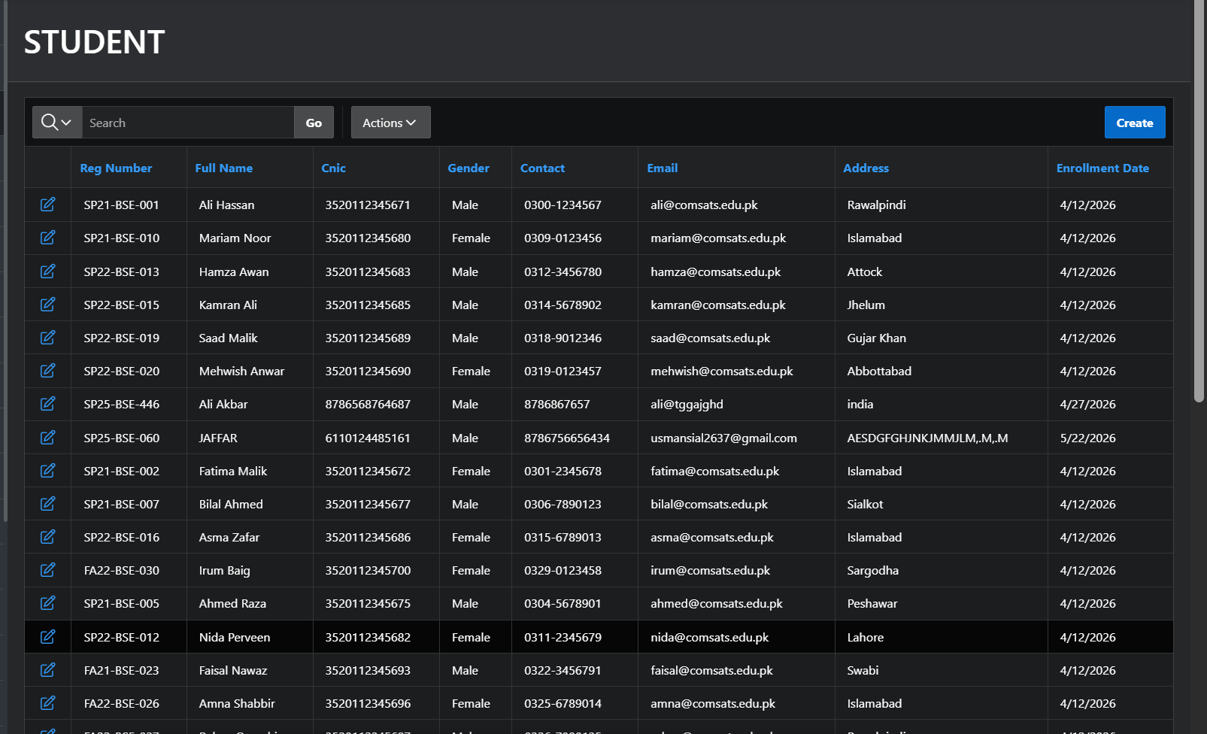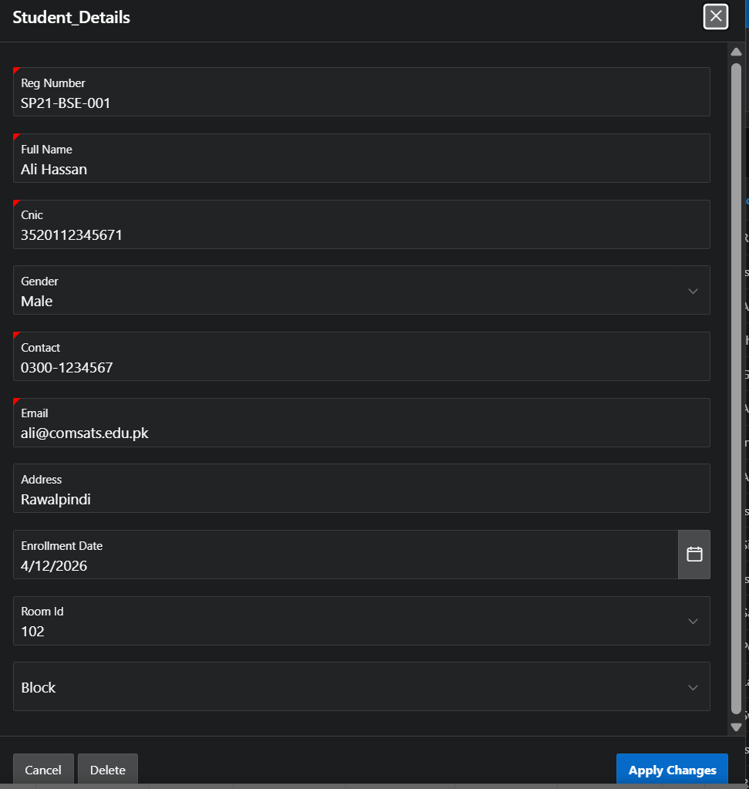

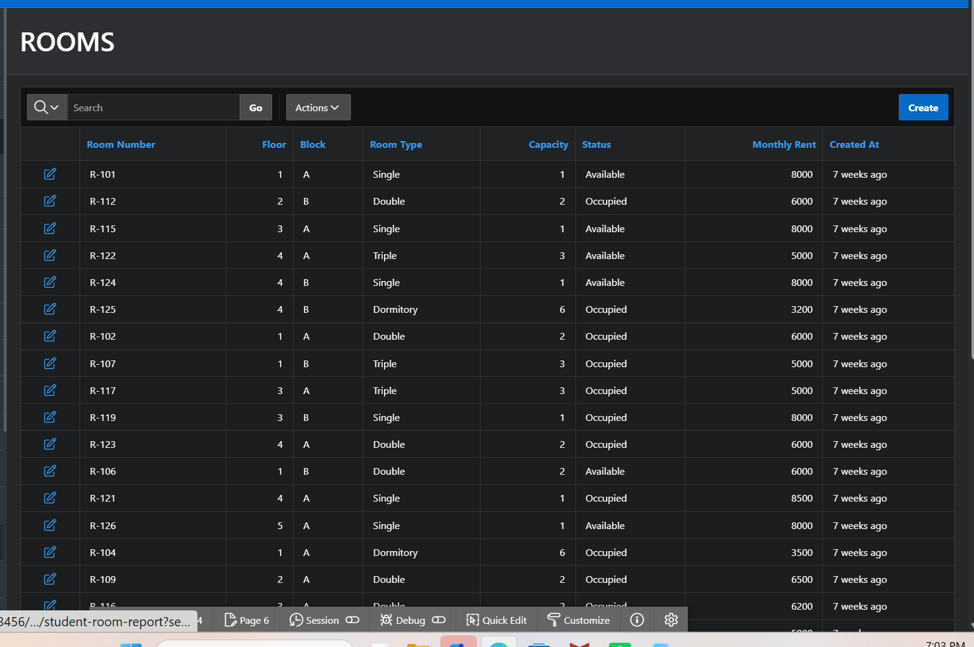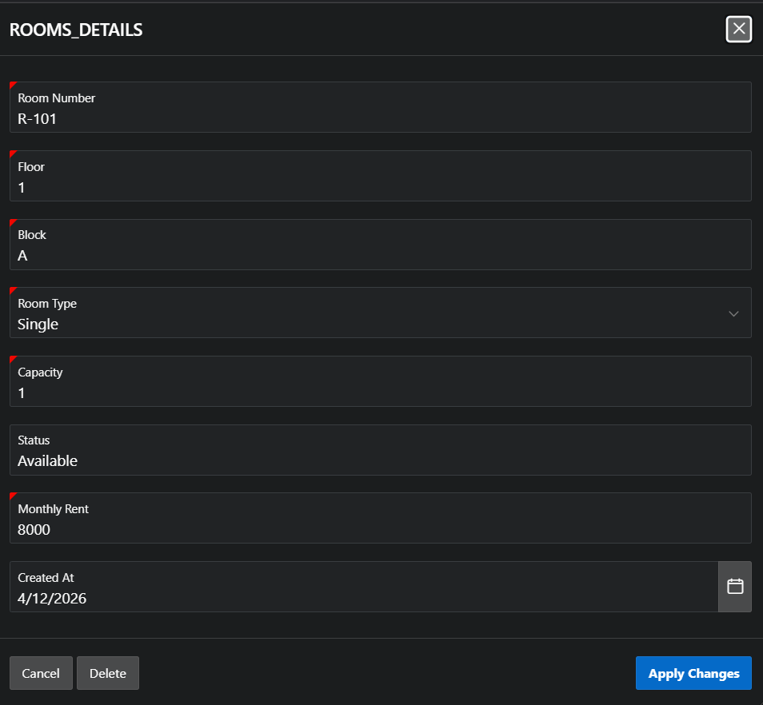

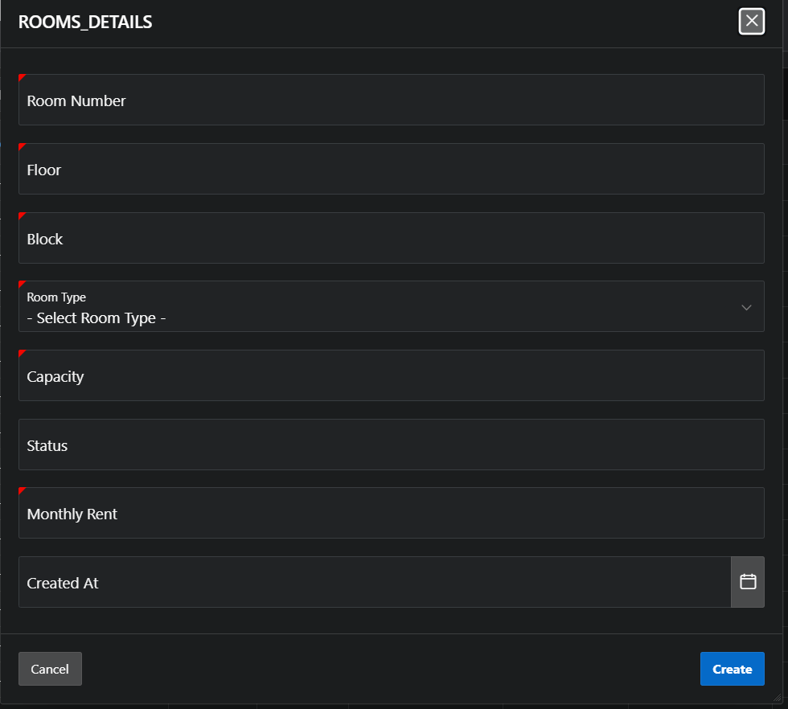

Part-V: SQL Queries & Advanced Operations

Query 1: Joining at Least 3 Tables
Business Need: Generate a comprehensive report listing each student's full name, their assigned room details, total amount paid, and any pending complaint count — useful for administrative review.

-- Comprehensive Student Report: STUDENT + ROOM + PAYMENT + COMPLAINT (4-Table JOIN)
SELECT
s.student_id,
s.full_name,
s.reg_number,
r.room_number,
r.room_type,
r.floor,
r.block,
NVL(SUM(p.amount), 0) AS total_paid,
COUNT(DISTINCT p.payment_id) AS payment_count,
COUNT(DISTINCT CASE WHEN c.status='Open'
THEN c.complaint_id END) AS open_complaints
FROM STUDENT s
JOIN ROOM r ON s.room_id = r.room_id
LEFT JOIN PAYMENT p ON p.student_id = s.student_id
AND p.status = 'Paid'
LEFT JOIN COMPLAINT c ON c.student_id = s.student_id
GROUP BY s.student_id, s.full_name, s.reg_number,
r.room_number, r.room_type, r.floor, r.block
ORDER BY s.full_name;

Query 2: Aggregation with GROUP BY
Business Need: Find total and average revenue collected per room type, along with maintenance request counts — for hostel financial and operational analysis.

-- Revenue Summary per Room Type with Maintenance Count
SELECT
r.room_type,
COUNT(DISTINCT s.student_id) AS total_students,
SUM(p.amount) AS total_revenue,
ROUND(AVG(p.amount), 2) AS avg_payment,
MAX(p.amount) AS max_payment,
MIN(p.amount) AS min_payment,
COUNT(DISTINCT m.request_id) AS maintenance_count
FROM ROOM r
JOIN STUDENT s ON s.room_id = r.room_id
JOIN PAYMENT p ON p.student_id = s.student_id
LEFT JOIN MAINTENANCE m ON m.room_id = r.room_id
WHERE p.status = 'Paid'
GROUP BY r.room_type
ORDER BY total_revenue DESC;

Query 3: Subquery Example
Business Need: Identify students whose total payments are below the overall average — to flag potential payment risk cases.

-- Students with Total Paid Below the Average (Subquery in HAVING)
SELECT
s.student_id,
s.full_name,
s.reg_number,
SUM(p.amount) AS total_paid
FROM STUDENT s
JOIN PAYMENT p ON p.student_id = s.student_id
WHERE p.status = 'Paid'
GROUP BY s.student_id, s.full_name, s.reg_number
HAVING SUM(p.amount) < (
SELECT AVG(total)
FROM (
SELECT SUM(amount) AS total
FROM PAYMENT
WHERE status = 'Paid'
GROUP BY student_id
)
)
ORDER BY total_paid ASC;

Query 4: UNION / INTERSECT
Business Need: List all staff members who are either assigned to a maintenance task OR who have approved a visitor entry OR who resolved a complaint — a complete staff involvement report.

-- Staff Involved in Maintenance, Visitor Approvals, or Complaint Resolution (UNION)
SELECT staff_id, full_name, role, 'Maintenance' AS involvement_type
FROM STAFF
WHERE staff_id IN (SELECT DISTINCT assigned_to
FROM MAINTENANCE WHERE assigned_to IS NOT NULL)
UNION
SELECT staff_id, full_name, role, 'Visitor Approval' AS involvement_type
FROM STAFF
WHERE staff_id IN (SELECT DISTINCT approved_by
FROM VISITOR WHERE approved_by IS NOT NULL)
UNION
SELECT staff_id, full_name, role, 'Complaint Resolution' AS involvement_type
FROM STAFF
WHERE staff_id IN (SELECT DISTINCT resolved_by
FROM COMPLAINT WHERE resolved_by IS NOT NULL)
ORDER BY full_name;

Bonus Query: Cross-Entity Analytics
Business Need: For each student, show their room type, number of laundry requests, approved leaves, and open complaints — a 360-degree student hostel activity summary.

-- Student Activity Summary (STUDENT + ROOM + LAUNDRY + ROOM_TRANSFER + COMPLAINT)
SELECT
s.student_id,
s.full_name,
r.room_type,
r.room_number,
COUNT(DISTINCT l.laundry_id) AS laundry_requests,
COUNT(DISTINCT CASE WHEN rt.status='Completed'
THEN rt.transfer_id END) AS completed_transfers,
COUNT(DISTINCT CASE WHEN c.status='Open'
THEN c.complaint_id END) AS open_complaints
FROM STUDENT s
JOIN ROOM r ON s.room_id = r.room_id
LEFT JOIN LAUNDRY l ON l.student_id = s.student_id
LEFT JOIN ROOM_TRANSFER rt ON rt.student_id = s.student_id
LEFT JOIN COMPLAINT c ON c.student_id = s.student_id
GROUP BY s.student_id, s.full_name, r.room_type, r.room_number
ORDER BY s.full_name;

